Sportking-ebid Admin
Bid Admin Login:
To login to ebid admin section open the url and login with the credentials given below:
https://sportking-ebid.com/by_product/bid_admin/login.php
super@admin.com / !119Sup11!
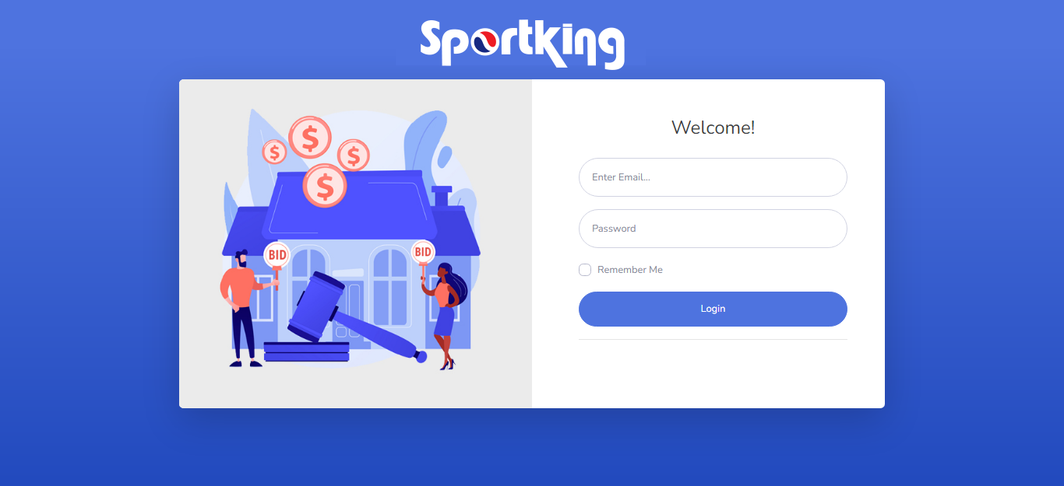
Add New Bid:
Go to Add Bid > Add, a form will open with all the input fields to add a new bid. Just fill the form with required details and press Save button. See the image below:
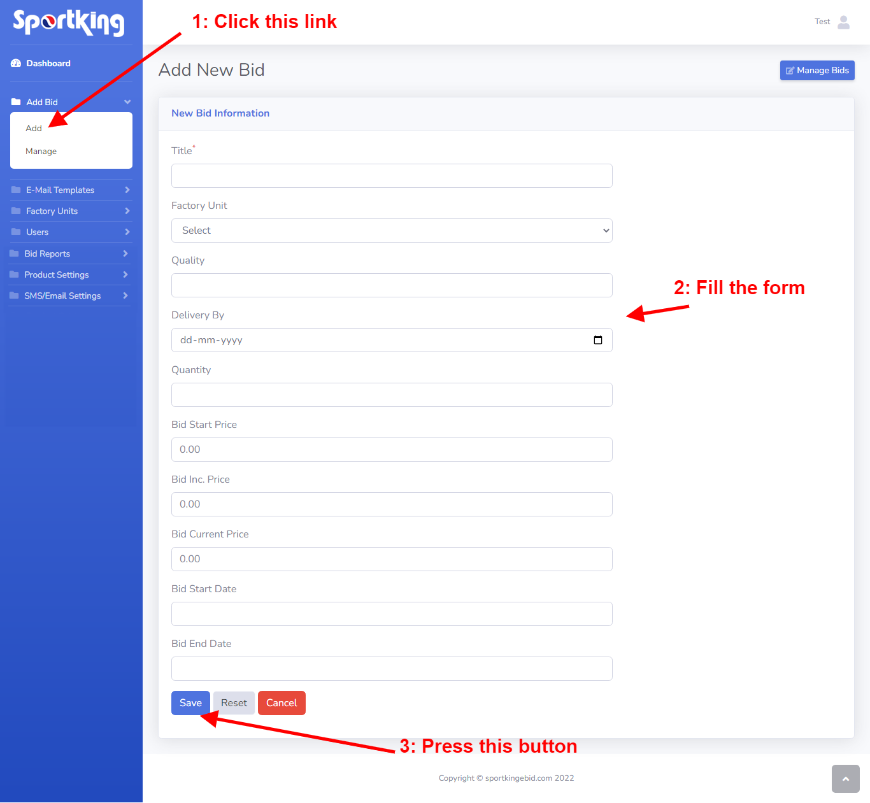
View All/Manage Bids:
Go to Add Bid > Manage, It will open a page with listing of all the bids added by the admin. And as soon as the admin active the bid and email will be sent to all the active users. As shown in the image below:
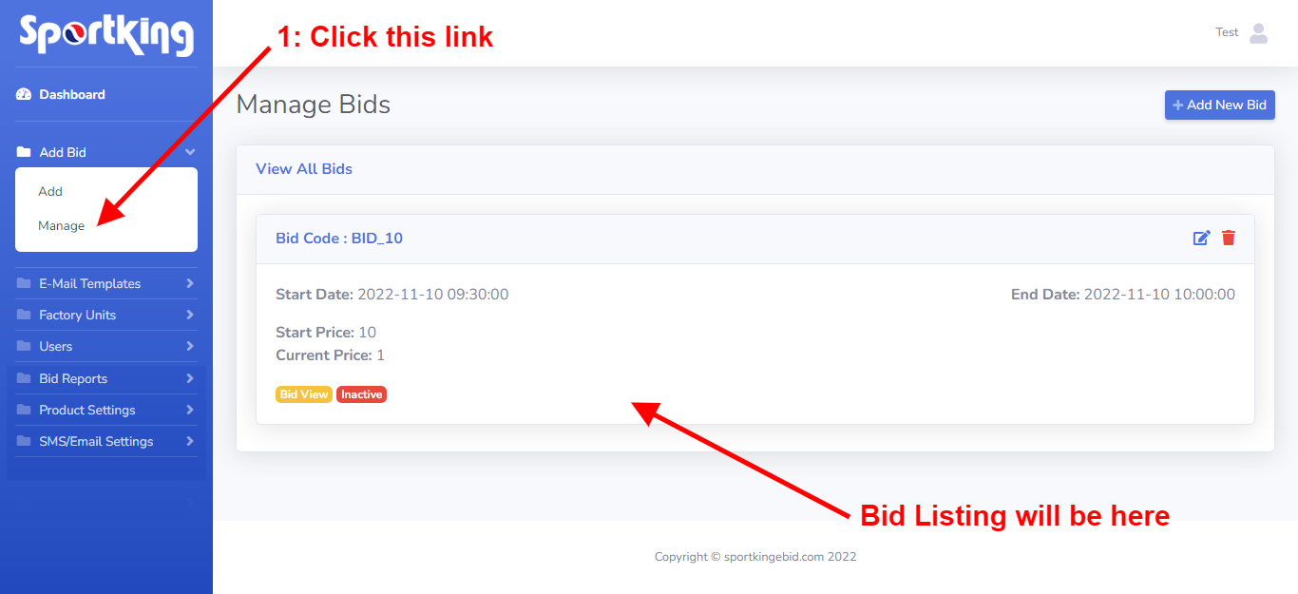
Add/Manage Email Templates:
Go to E-mail Templates and click Add link to add new email template and Click on Manage link to edit or update an existing email template:
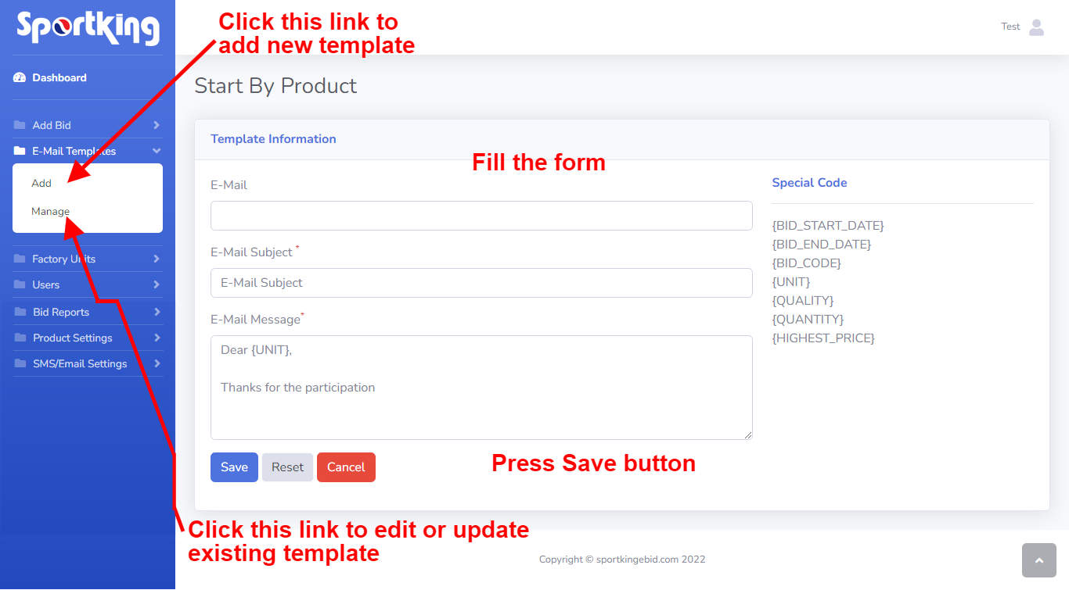
Add Factory Unit:
Go to Factory Unit > Add, a form will open with all the required input fields, Just fill the form and press Save button, the unit will be added in the system.
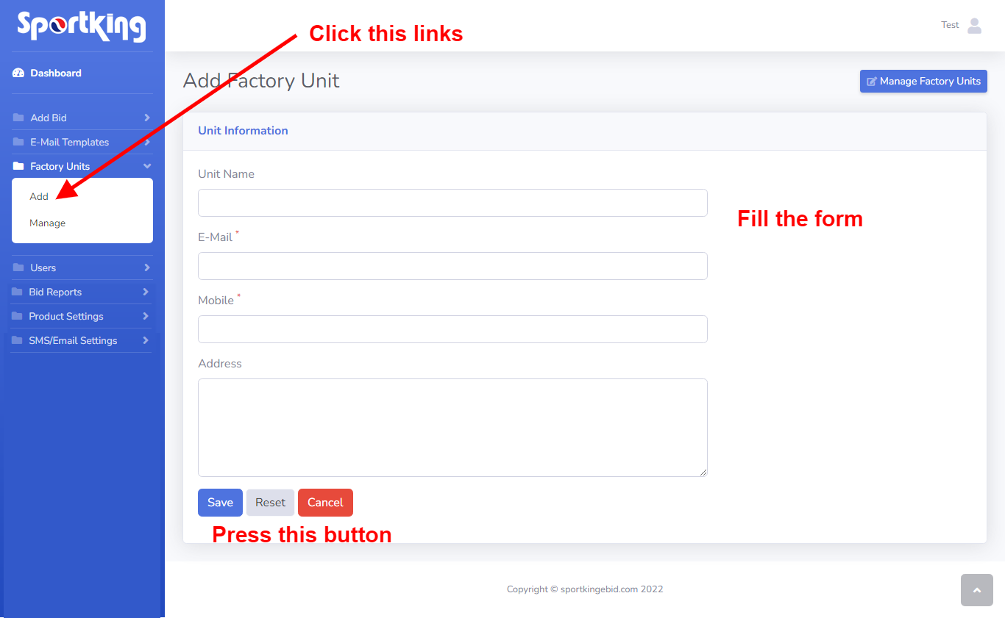
Manage Factory Units:
Go to Factory Unit > Manage link, A page will open to display listing of all the factory units added in the system. And from there admin can Edit or Delete any unit as and when required as shown in the image below:
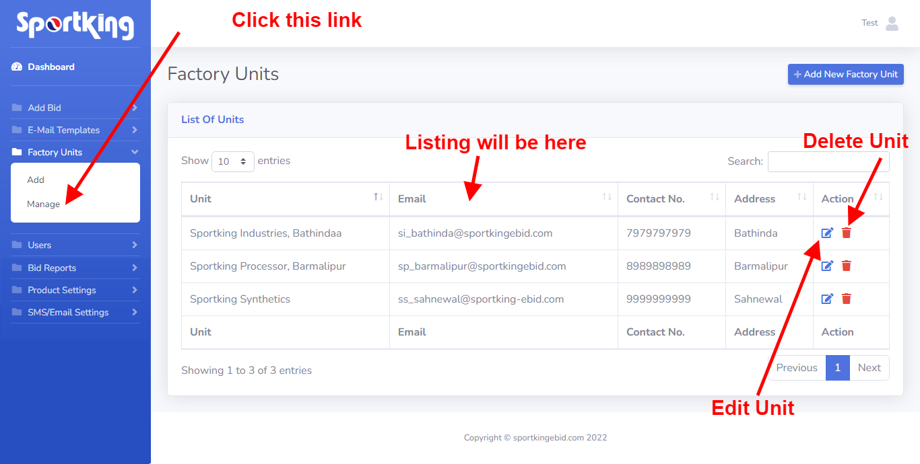
Add User:
Go to Users > Add, a form will open with all the required input fields, Just fill the form and press Add button, the user will be added in the system. See image below:
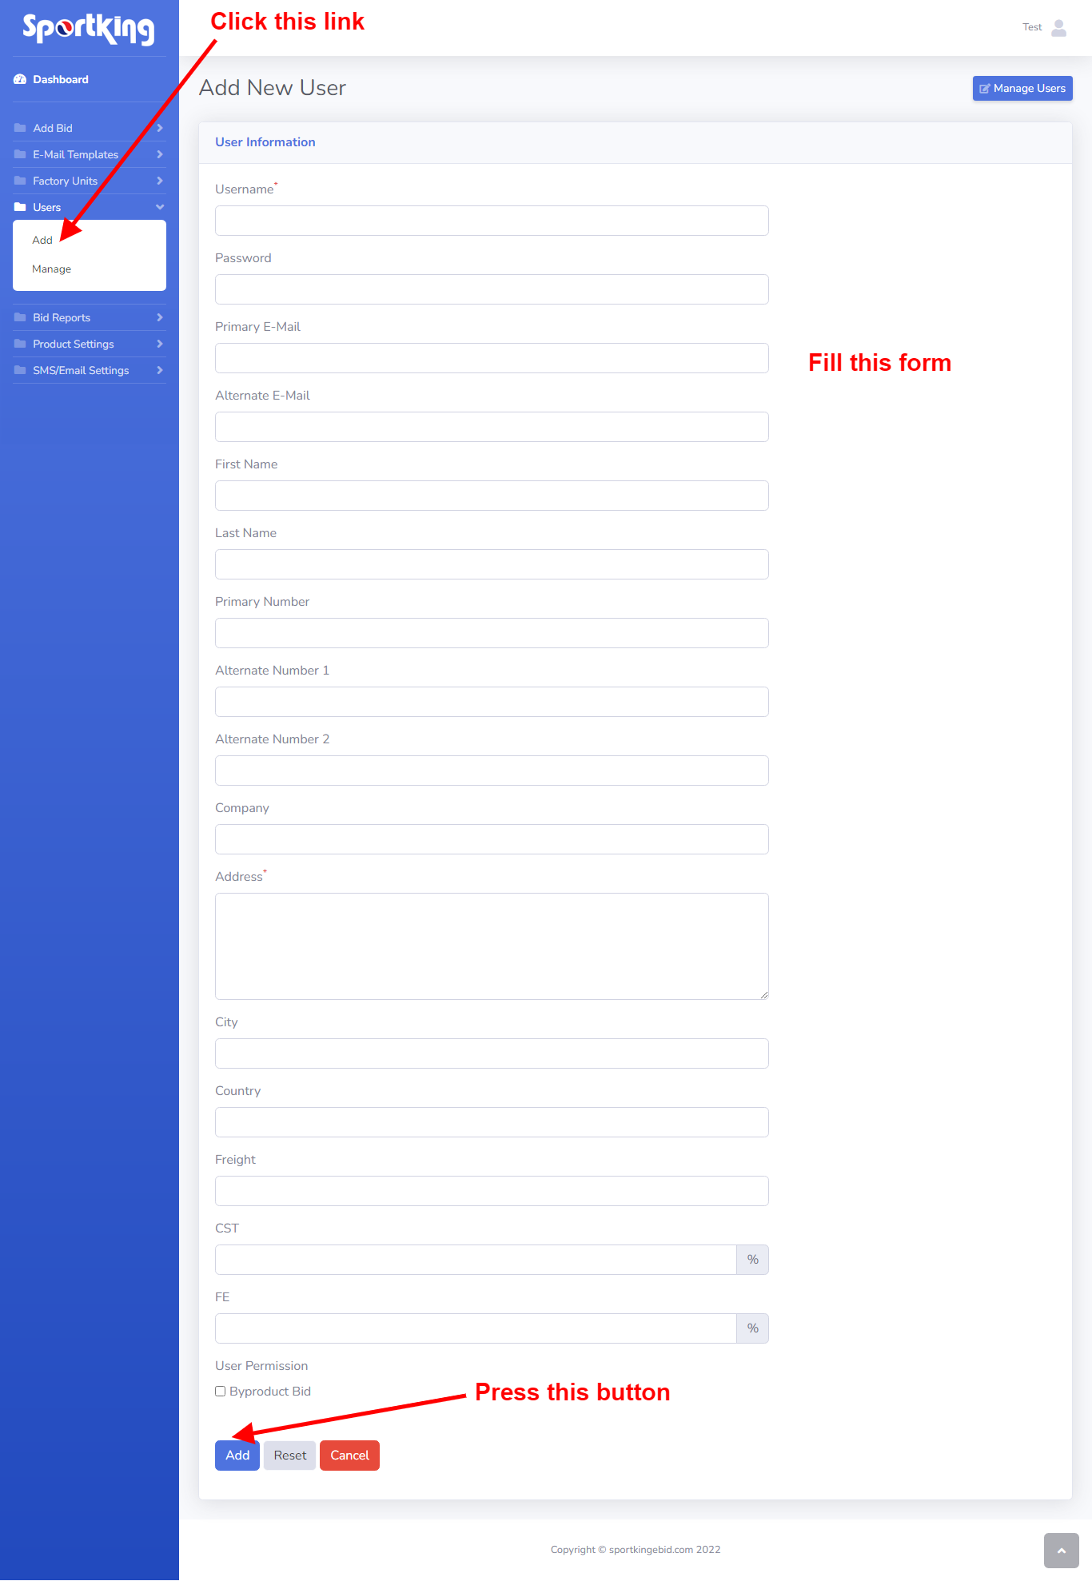
Manage Users:
Go to Users > Manage link, A page will open to display listing of all the users added in the system. And from there admin can Edit, Delete, Activate or Deactivate any user as and when required as shown in the image below:
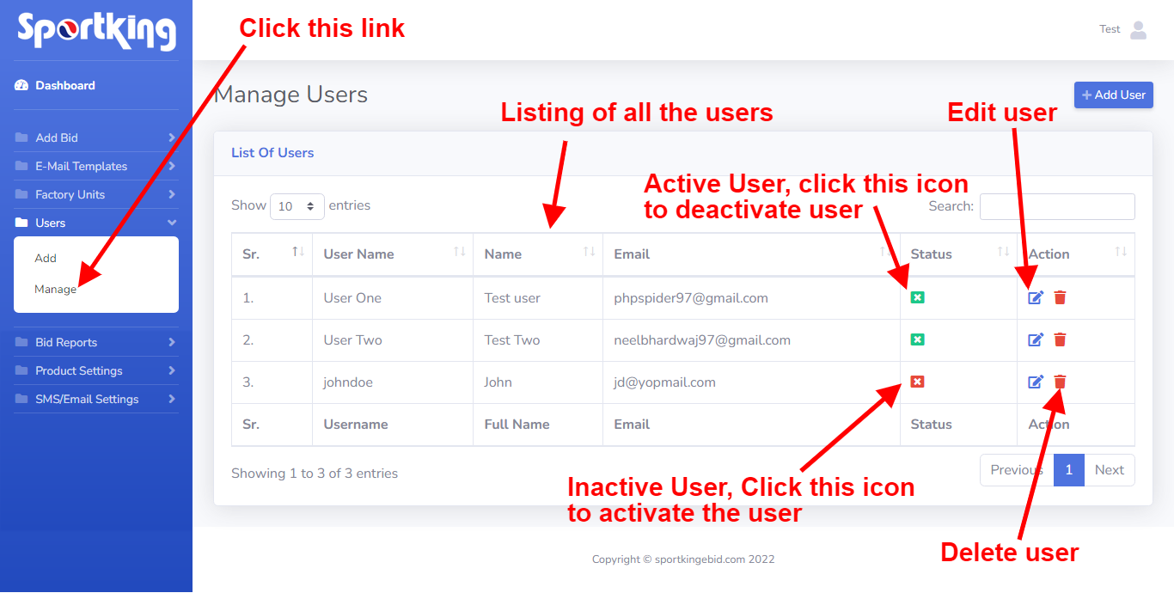
Product Settings:
Go to Product Settings > Manage, a form will open with all the input fields of settings, just fill the form and press Update Settings button as shown in the image below:
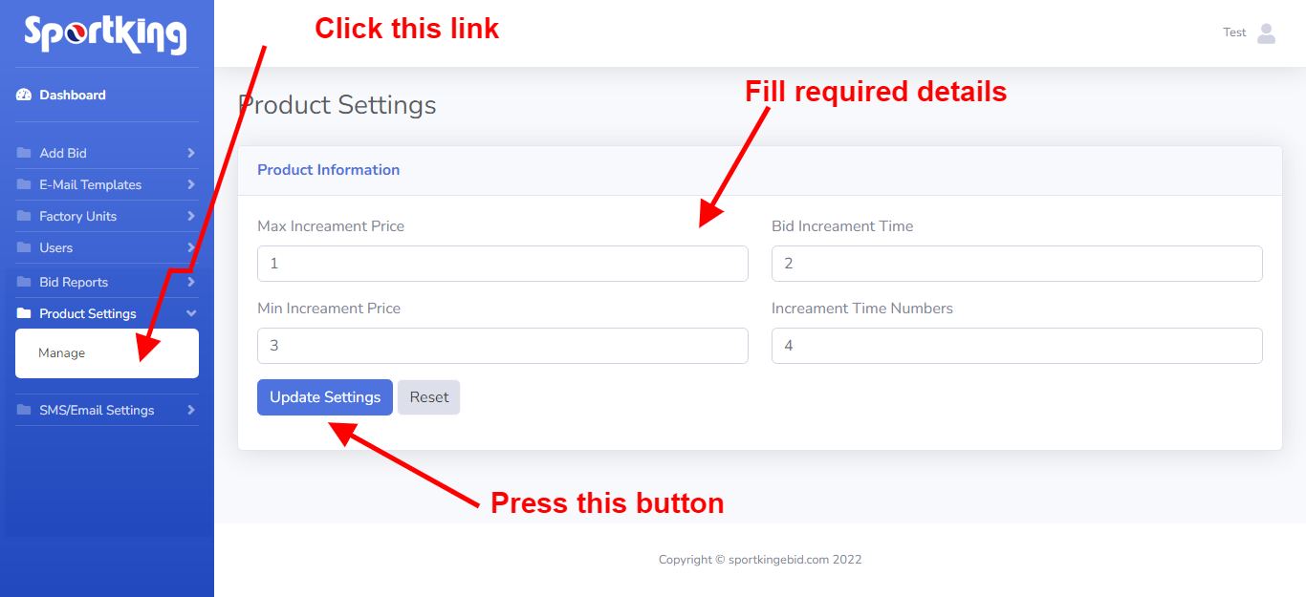
SMS/Email Settings:
Go to SMS/Email Settings > Manage, a form will open with all the input fields of settings, just fill the form and press Update Settings button as shown in the image below:
